**Chapter 5**

**How to Install “Data & PC Securer”:**

1. Run the CD which has the “Data & PC Securer” setup.
2. Then run the setup.
3. The setup runs in full screen:

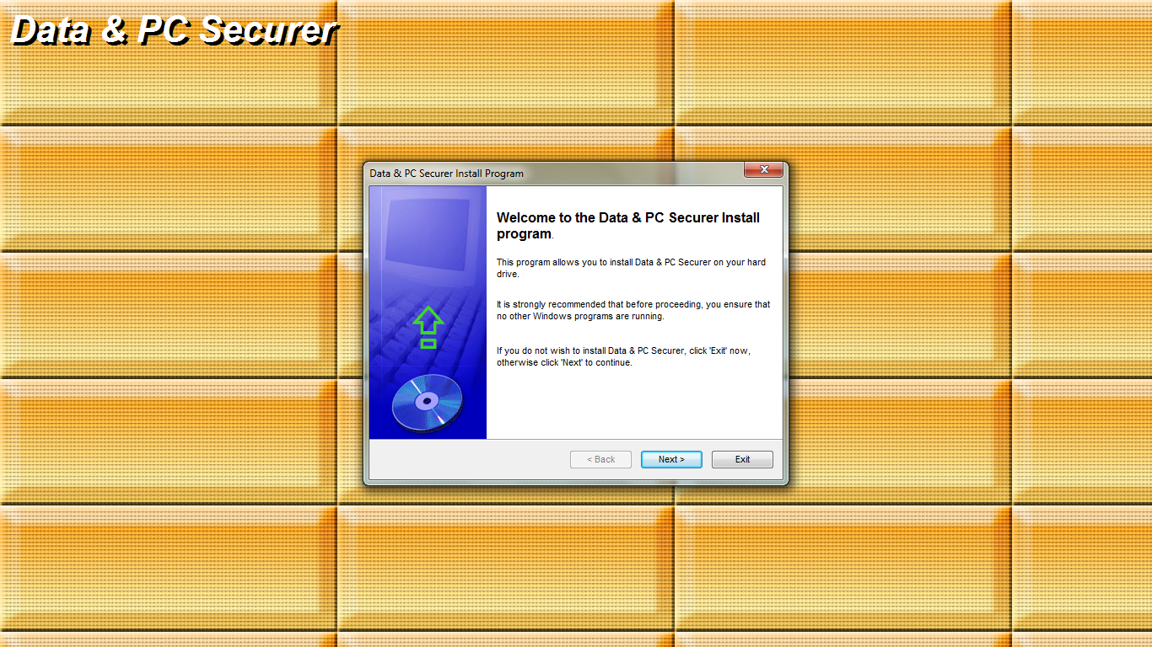

Fig 5.1: Setup at a glance

1. Click on next.

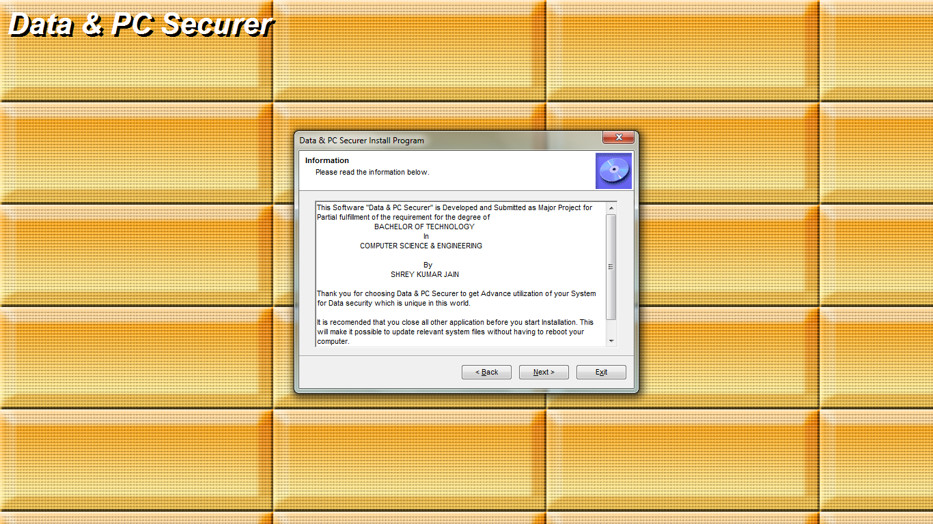Fig 5.2: Setup at a glance

1. Click on next.

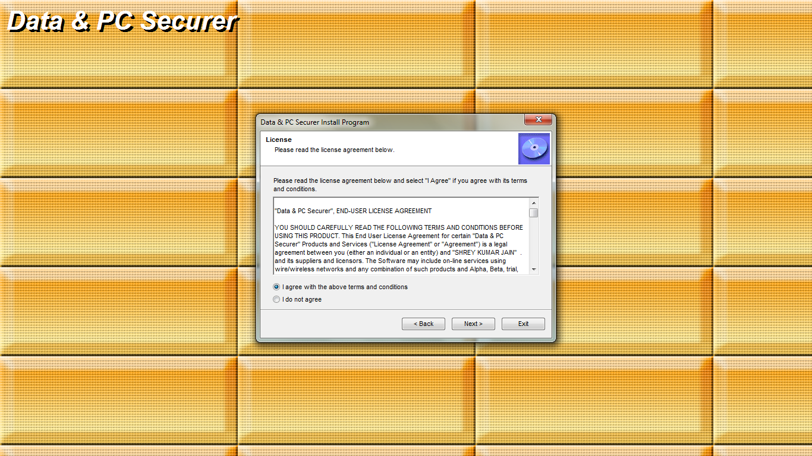

Fig 5.3: Setup at a glance

1. Select I agree Radio button after reading all Licence terms.
2. Then click next.

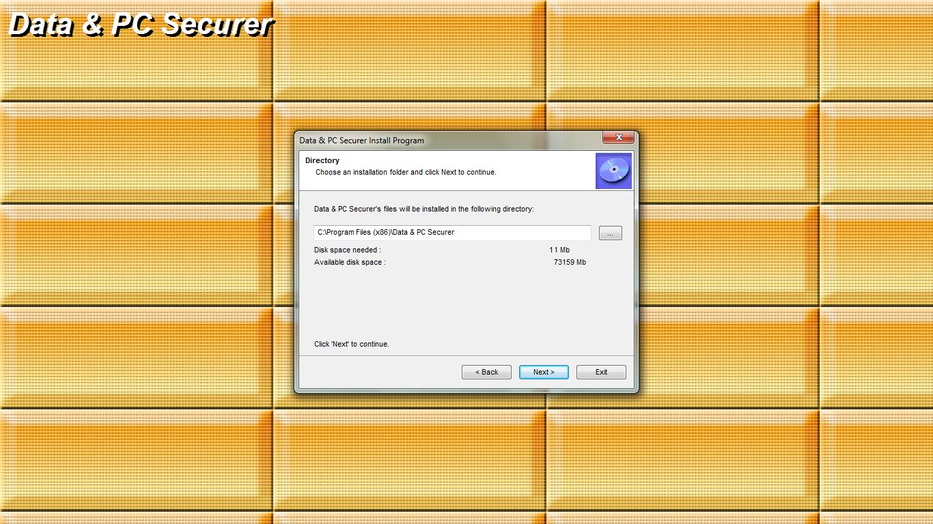

Fig 5.4: Setup at a glance

Clicking Next will install “Data & PC Securer”

The installation file is created by the help of “Install Creator- by Click team” ver 2.0.